IPv4 Address (Part 2)

Conversion from binary to dotted decimal

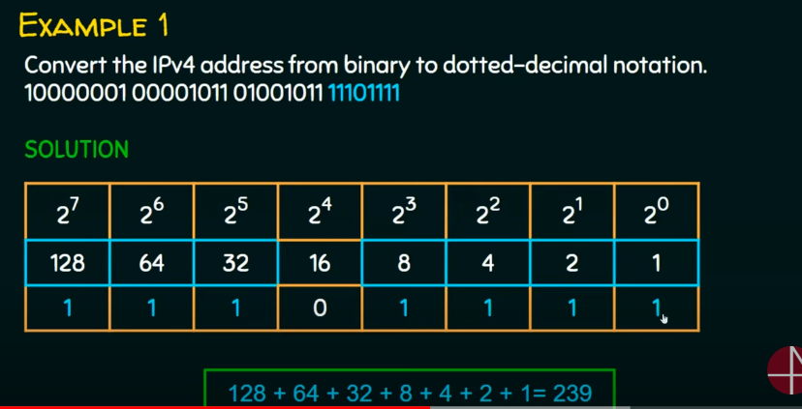

Conversion from dotted decimal to binary

